Partner Invitation Flowchart

Diagram
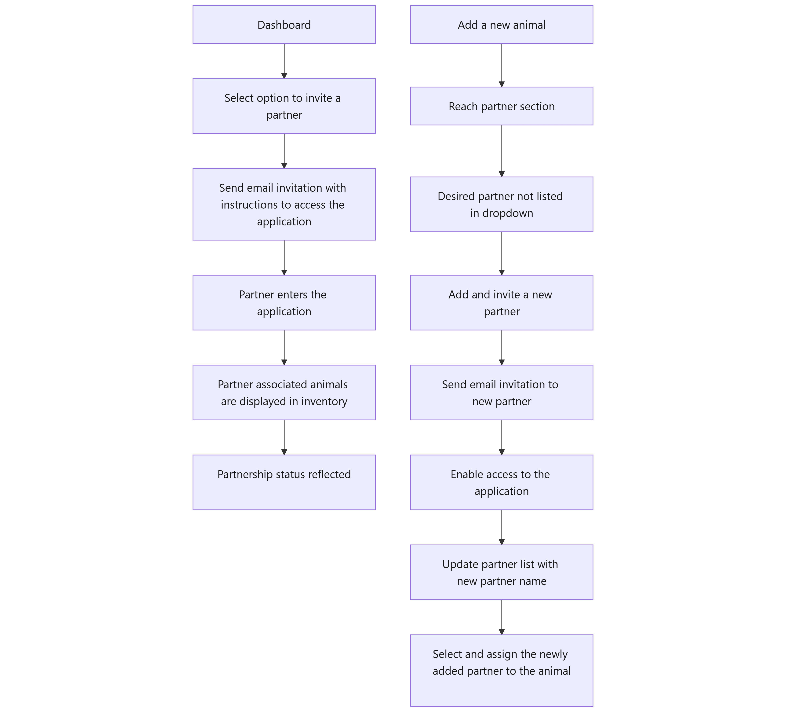

Diagram Markdown
flowchart TD
DashboardNode[Dashboard]
InviteOptionNode[Select option to invite a partner]
EmailInviteNode[Send email invitation with instructions to access the application]
PartnerAccessNode[Partner enters the application]
InventoryNode[Partner associated animals are displayed in inventory]
PartnerStatusNode[Partnership status reflected]
AddAnimalNode[Add a new animal]
PartnerSectionNode[Reach partner section]
DropdownCheckNode[Desired partner not listed in dropdown]
AddNewPartnerNode[Add and invite a new partner]
PartnerEmailNode[Send email invitation to new partner]
EnableAccessNode[Enable access to the application]
UpdateListNode[Update partner list with new partner name]
AssignPartnerNode[Select and assign the newly added partner to the animal]
DashboardNode --> InviteOptionNode
InviteOptionNode --> EmailInviteNode
EmailInviteNode --> PartnerAccessNode
PartnerAccessNode --> InventoryNode
InventoryNode --> PartnerStatusNode
AddAnimalNode --> PartnerSectionNode
PartnerSectionNode --> DropdownCheckNode
DropdownCheckNode --> AddNewPartnerNode
AddNewPartnerNode --> PartnerEmailNode
PartnerEmailNode --> EnableAccessNode
EnableAccessNode --> UpdateListNode
UpdateListNode --> AssignPartnerNode

